Supplemental Material for Fisheries Report 49: 2025 Michigan Great Lakes Recreational Fisheries:
Creel Surveys, Charter Reporting, and Historical Trends
This supplemental Excel file provides expanded tables, detailed data, and appendices referenced in the associated journal publication.
Archival information for research purposes.
LINK TO PUBLICATION PDF

Lake Erie Creel Re-estimation
Zhenming Su,
State-wide Angler Survey Program,
Fisheries Division, MDNR
IFR, Ann Arbor, MI

October 23, 2025

Regular creel surveys for the Michigan part of Lake Erie have been conducted annually by the Fisheries Division of MDNR since 1986. During these years, several changes have been made to the configurations of creel survey sites, survey methods, and estimation techniques. These changes have made the old creel estimates of Lake Erie made before this writing incompatible over years. To correct this problem, I conducted this project of creel re-estimation for Lake Erie during FALL 2025 using the up-to-date estimation program (MiCreel Estimator) and the research findings made in Su and Liu (2025).
This document briefly describes the problems that the re-estimation attempted to solve and the estimation process.

Changes in survey creel site configurations
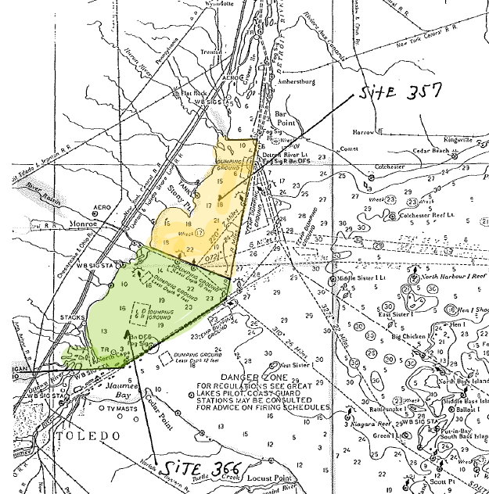
From 1986 to 1989, Lake Erie was divided into two areas (sites) by a line starting at the mouth of Raisin River and perpendicular to the shoreline: 357 (North area from Pointe Mouillee to Mouth of Raisin River), and 366 (South area from Mouth of Raisin River to MI-OH state line). Both interviews and counts were recorded using this site scheme. Interviews were conducted by ground creel clerks (or technicians). Counts were conducted by airplanes. Estimates were made for fishing sites 357 and 366 separately in these years.
From 1990 to 1994, sites 357 and 366 were still used as the interview sites. But counts were recorded using both the 357-366 scheme and an additional grid-site scheme (grids 702 and 801) by the aerial survey method. These two site schemes are not compatible with each other at the dividing lines. Estimates were still made for fishing sites 357 and 366 in these years. Interviews were not recorded for grid sites 702 and 801.
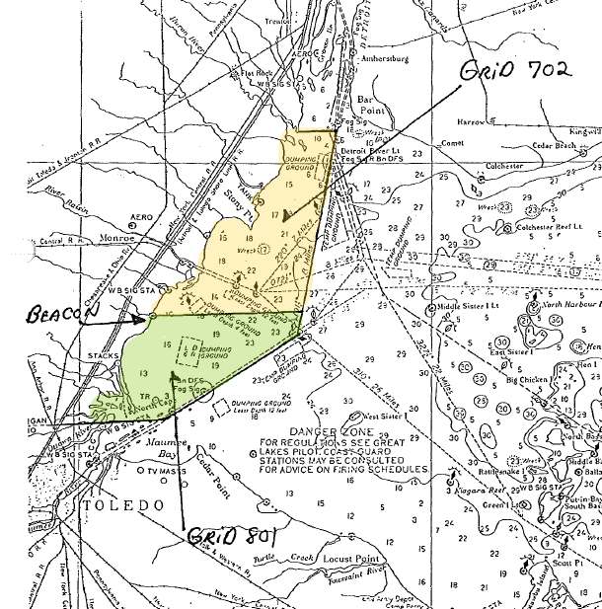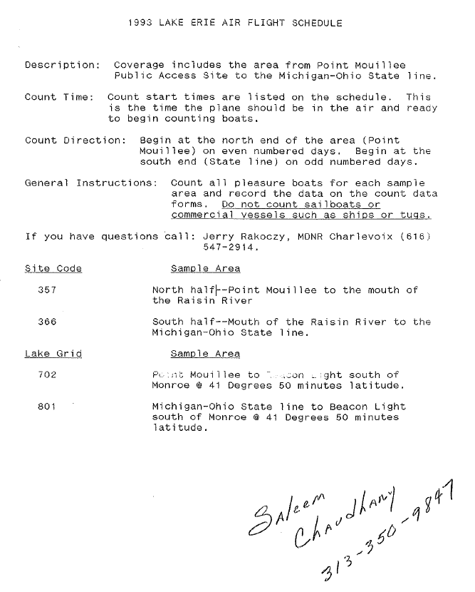
As a result, the creel estimates for Lake Erie from 1986 to 1989 were made for site 357 and 366. It seems that the old site 357 included a part of the new site 500 (Detroit River mouth area) indicated below.
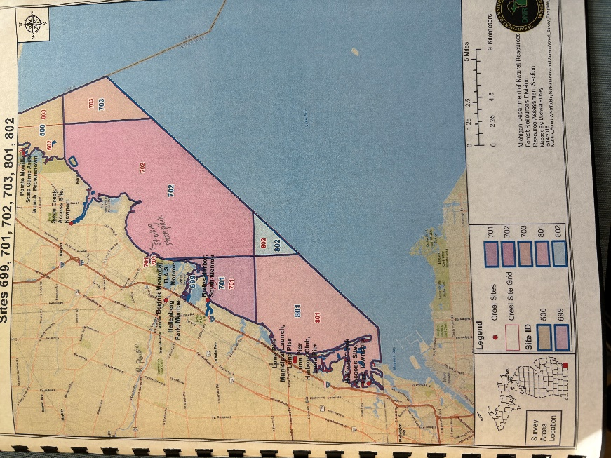
In 1995, the creel sites of Lake Erie were changed to the current system of Lake grid sites for both interviews and counts. Estimates were made for each of the fishing sites since 1995.
Due to these changes in site designations, estimates of fishing sites from these three periods are not comparable. However, lake-wide estimates should be comparable among the three periods.
Interviews and counts were not made for site 500 from 1995 to 2015 but have been made for it since 2016. So estimates for 500 were available but are not included in the estimates for Lake Erie provided. The estimates will be designed as for Detroit River (DR).

Changes in survey and estimation methods
Creel surveys conducted for Lake Erie from 1986 to 2022 followed the traditional interview-count method (Lockwood et al. 1999, Su and Clapp 2013, Su and He 2013, Su and Liu 2025). Since 2023, the bus-route method as documented in Su and Liu 2025 has been used for Lake Erie creel surveys.
Lockwood et al. (1999) documented the estimation methods for the interview-count method used for the inland and Great Lakes waters of Michigan since 1998. Estimation equations for creel surveys conducted prior to 1998 are given in Appendix 1 of Lockwood et al. (1999). It is highly likely that creel survey estimates in documents published prior to 1998 that reference the survey methods manual (Schneider et al. 1981) used the equations contained in Appendix 1, since this set of equations had remained substantially unchanged since the 1960’s. MDNR, Fisheries Division maintains a survey methods manual (Schneider et al. 1981) describing (among other things) how creel survey estimates are made (e.g., Ryckman 1981). Many documents cite this as a source for detail on how these estimates are made.
Since 2023, the bus-route survey method (Su and Liu 2025) has been used for the creel surveys conducted for Lake Erie. Su and Liu (2025) conducted comprehensive comparisons of the traditional and bus-route survey methods for the Lake Erie creel surveys.
In Su and Liu (2025), using concurrent field surveys and Monte Carlo simulations, bus-route and aerial-access creel survey methods were evaluated and compared for the recreational fisheries of the Michigan waters of Lake Erie. The two methods yielded comparable estimates for the 2021 surveys. The bus-route method was more cost-effective than the aerial-access method. The simulations show that the bus-route method produced unbiased estimates and was statistically more efficient than the aerial-access method. The simulations indicate that the aerial count method used for Lake Erie was subject to an often overlooked undercoverage bias due to its inability to cover nighttime fishing. Simulations allowed for the identification of estimators with relatively small bias under certain conditions for the aerial count method.

Correct bias in the traditional aerial-count surveys from 1986 to 2022
For the aerial-count surveys traditionally conducted for Lake Erie, a daily fishing effort is estimated by expanding the mean daily sample boat count (${\overline{B}}_{d}$) by an expansion factor (F): ${\hat{BH}}_{d}=F{×\overline{B}}_{d}$. For the aerial count survey used for Lake Erie, the count-time sampling period is limited to the daytime period. Because fishing trips in this area are concentrated in the middle-day period, ${\overline{B}}_{d}$ can be higher than the true mean count that would be obtained from the entire fishing day. Furthermore, F was set to the average daily fishable hours (D) for each month (See Table 1). As a result, historical estimates of effort and catch for Lake Erie are over-estimated by a large amount (up to 30%).
Based on the simulation results of Su and Liu (2025), it appears that F values near or slightly larger than the day-time hours (L) for each month (Table 1), such as 13 h for July, may be the preferred values for estimating fishing effort and harvest in aerial-access surveys for Lake Erie, rather than F values close to D.
Table 1. Survey designs used the creel surveys of the Michigan waters of Lake Erie.
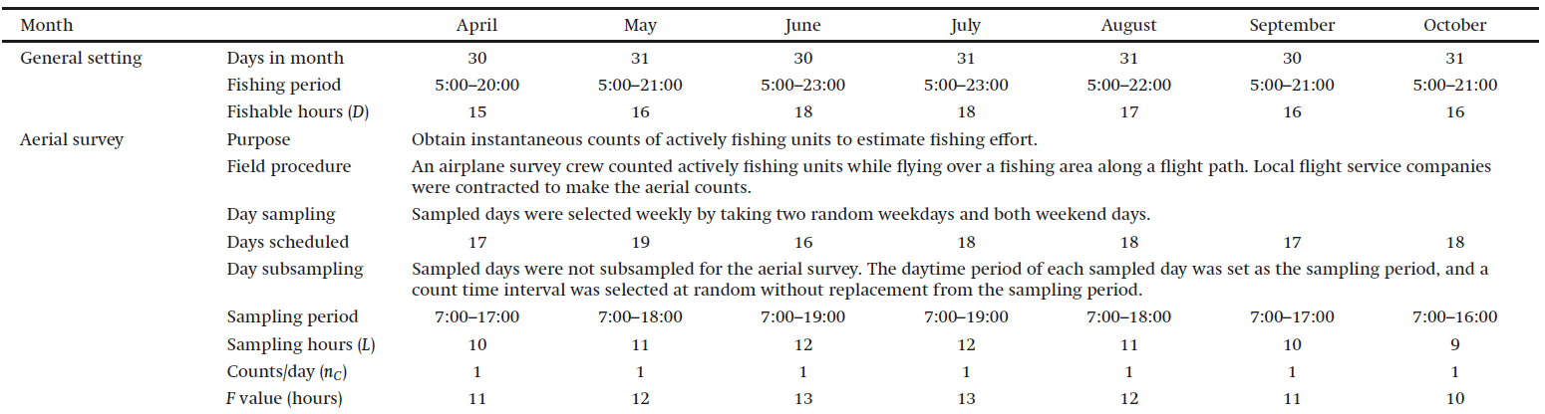
Based on these results, I used the F values of Aerial survey listed in Table 1 to re-estimate the creel survey data of Lake Erie conducted from 1986 to 2022. This would correct the positive bias that existed in the old estimates.

Correct mis-adjustment of non-fishing aerial counts from 2009 to 2016
During 2009 to 2016, there is a misalignment between the air and clerk Instructions regarding how boats were counted. For the pilot, it was instructed that the pilot only counts boats that appear to be fishing. This means excluding all boats running across the lake (visible wake), boats pulling water skiers or tubers, jet skis, sail boats, and moored boats. For the clerks, it was still assumed that pilots can’t differentiate between fishing and non-fishing boats, and let the clerks to interview non-fishing boats, EXCEPT sailboats. Due to this mis-understanding of what kinds of boats were counted by the pilot, the old estimates were made by assuming the pilot counted all kinds of boats, and used non-fishing ratios to adjust the supposed non-fishing boats contained in the count data. However, this might cause underestimation of the actual estimates.
Therefore, estimates were re-run for 2009 to 2016 without the non-fishing ratio adjustment.

Impute missing interviews for sites 703 and 802
For the creel surveys conducted from 1995 to 2022, there were often counts made for the open-water grid sites 703 and 802, but there were no interviews available for them in some or all months. As a result, angler-hours, harvest, and catch can not be estimated for these two sites for some months. However, it is better to take advantage of the counts made for the two sites and interview information obtained from nearshore sites.
For this reason, I imputed interviews for 703 using the interviews made for 702, and did so for 802 using the interviews obtained for 701. The imputation was done by drawing a random sample of interviews from, say, site 702 for 703. The sample size was determined by the ratio of the total number of boat counts made for 703 to that of 702 for each month. This way, a set of sampled interviews was made each month for site 703 (or 802) when the site had no interview for that month. The sampled interviews and the actual counts were then used to make estimates for the missing months for the two sites.
A potential issue with the imputed interview sample is that the species composition is uncertain and some near-shore species can be included in the estimates for the off-shore sites 703 and 802.

References
Su, Z., H. Liu, 2025. Evaluation of Bus-route and Aerial-access Methods for Great Lakes Recreational Fisheries Surveys. Canadian Journal of Fisheries and Aquatic Sciences. https://cdnsciencepub.com/doi/abs/10.1139/cjfas-2024-0317. DOI.10.1139/cjfas-2024-0317
Su, Z., Clapp, D. 2013. Evaluation of sample design and estimation methods for Great Lakes angler surveys. Transactions of the American Fisheries Society 142(1): 234–246. (Reprint: https://www.researchgate.net/scientific-contributions/Zhenming-Su-2002898345)
Su, Z., He, J. 2013. Analysis of Lake Huron recreational fisheries data using models dealing with excessive zeros. Fisheries Research 148: 81– 89. http://dx.doi.org/10.1016/j.fishres.2013.08.012. (Reprint: https://www.researchgate.net/scientific-contributions/Zhenming-Su-2002898345)
Lockwood, R.N., Benjamin, D.M., and Bence, J.R. 1999. Estimating angling effort and catch from Michigan roving and access site angler survey data. Michigan Department of Natural Resources, Fisheries Research Report 2044, Ann Arbor.

