Supplemental Figures for 2025 Michigan Great Lakes Recreational Fisheries

Figure S1. Historical creel survey coverage by Great Lake management unit (2000–2025). Colored tiles indicate surveyed seasons; blank tiles indicate no sampling.
Lake Michigan
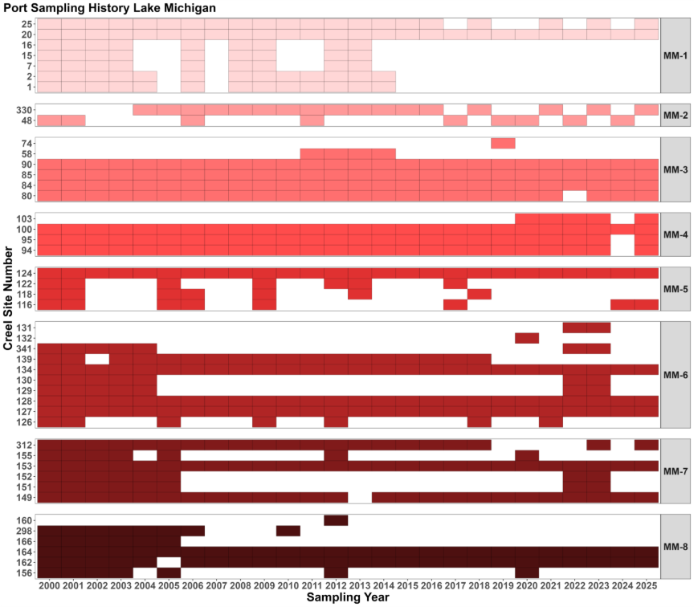

Lake Superior
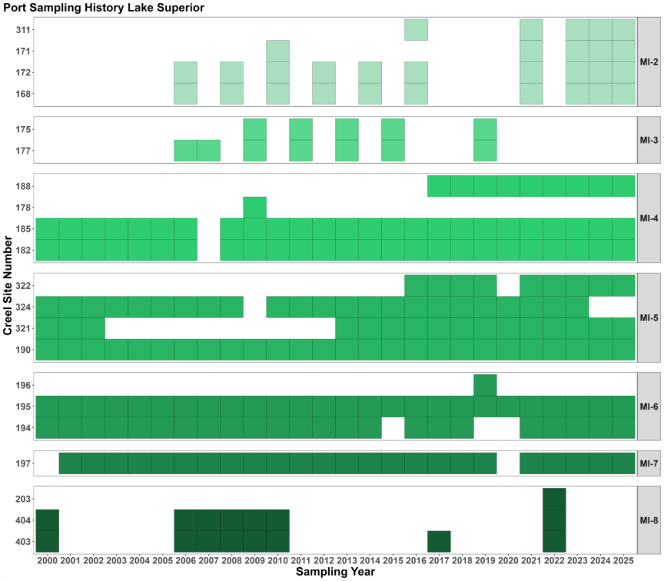

Lake Huron
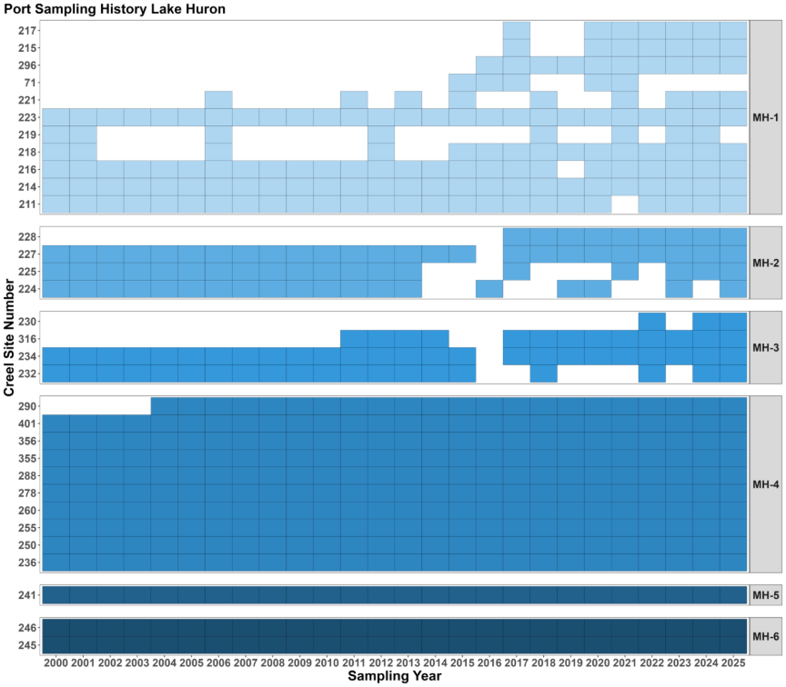

Lake Erie
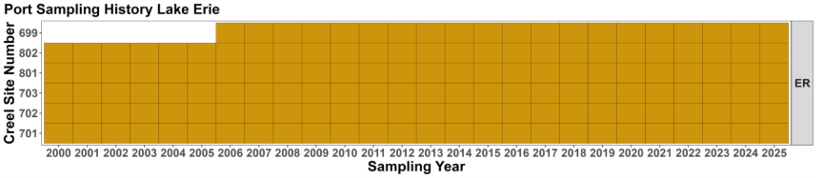

Figure S2. Lake Michigan 2025 harvest by species, month and Great Lake management unit.
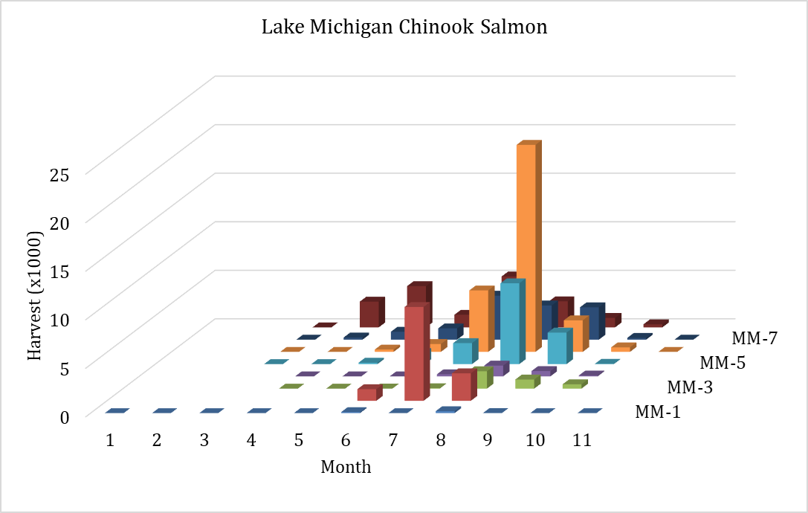
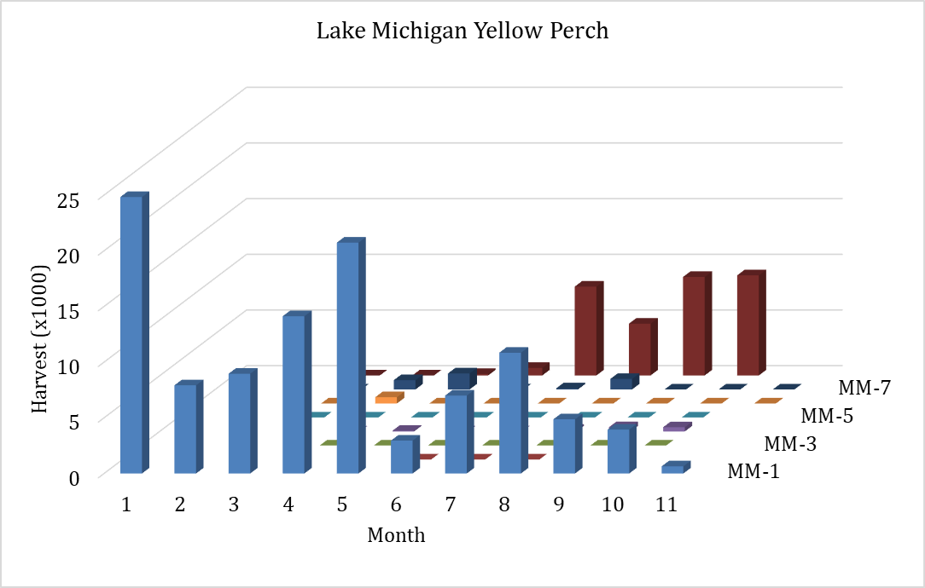

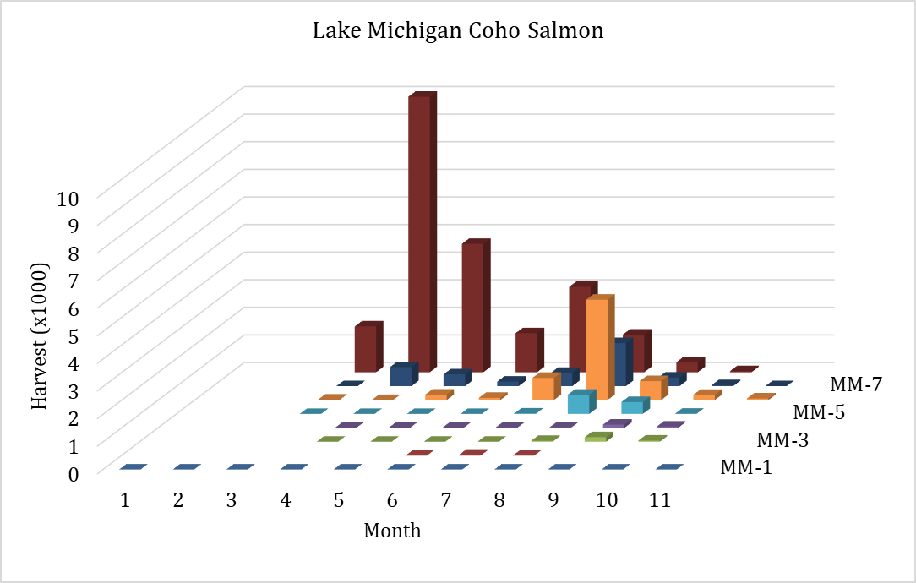
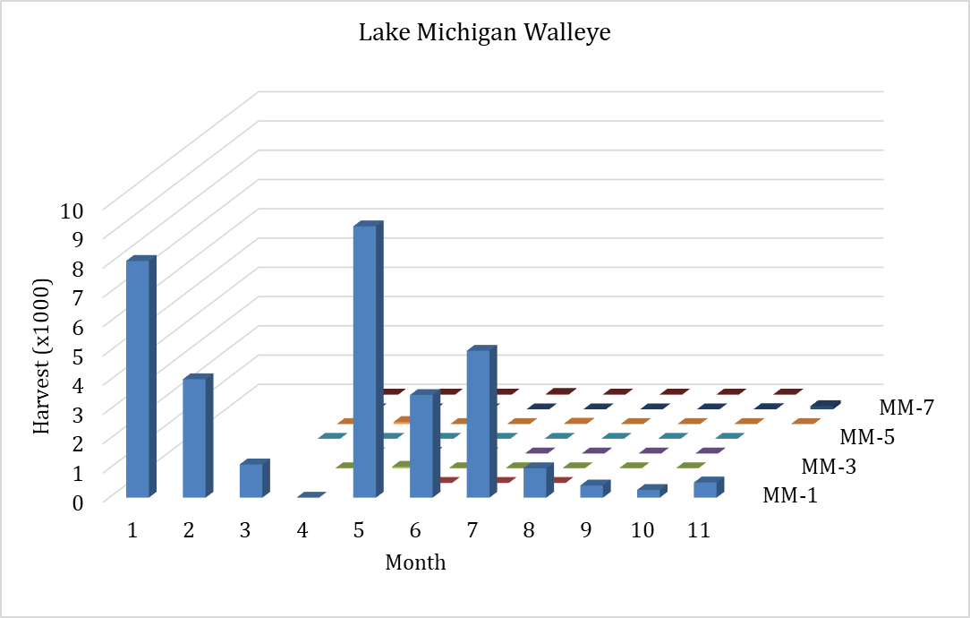

Figure S3. Lake Michigan 2025 release estimates (number of fish). OTH = combined harvest of all other species not shown individually. Species abbreviations can be found in Table A2.
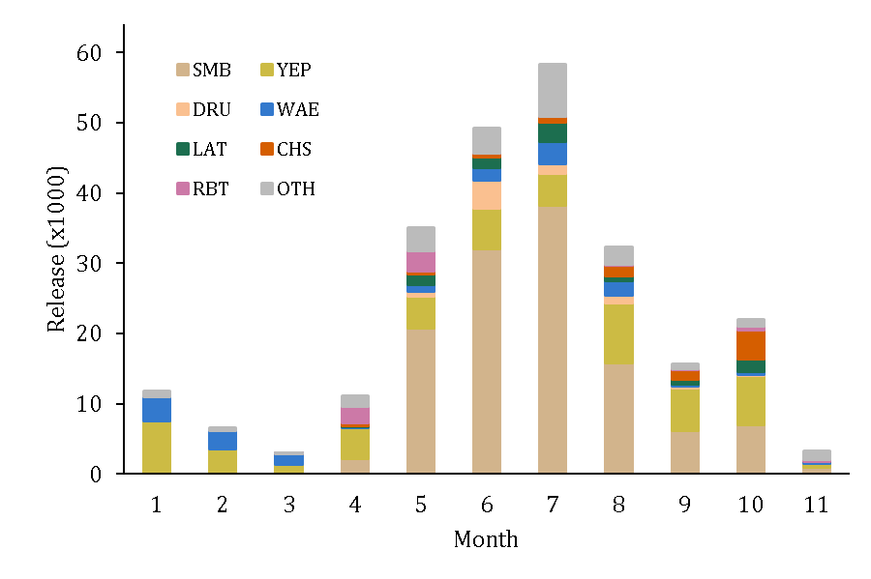

Figure S4. Lake Superior 2025 release estimates (number of fish). OTH = combined harvest of all other species not shown individually. Species abbreviations can be found in Table A2.
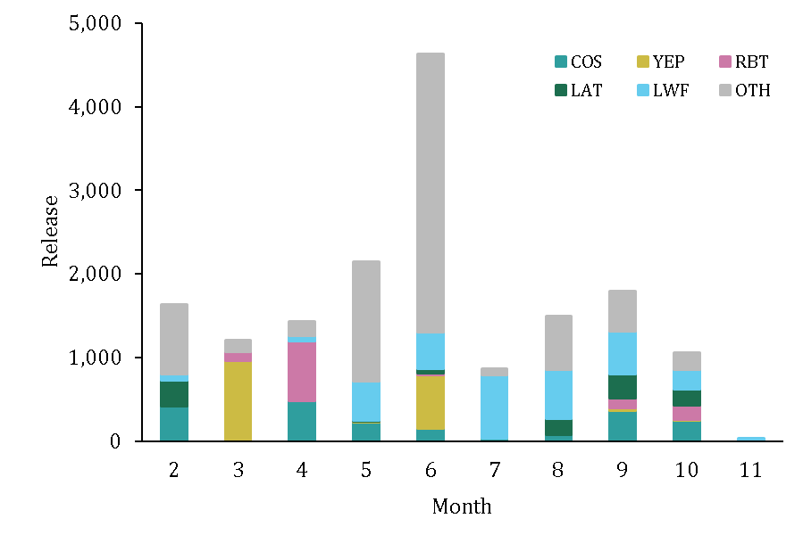

Figure S5. Saginaw Bay (MH4) 2025 release estimates (number of fish). OTH = combined harvest of all other species not shown individually. Species abbreviations can be found in Table A2.
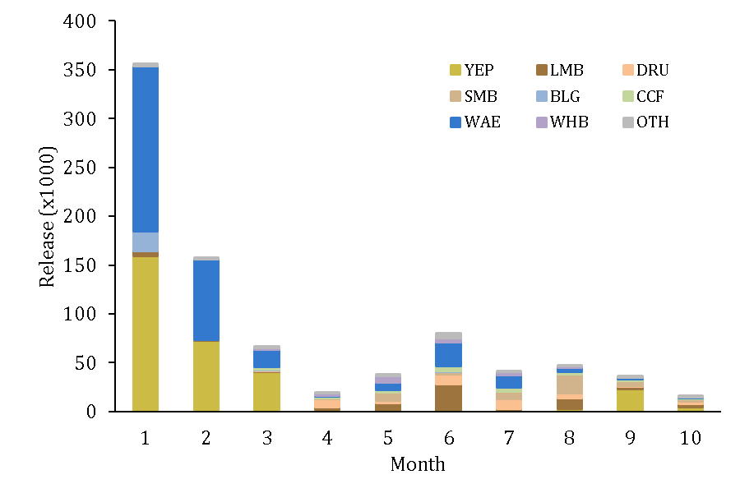

Figure S6. Lake Erie creel survey map showing creel sites. The Northern area is defined as the region containing sites 702 and 703, and the Southern area is defined as the region containing sites 701, 801, and 802.
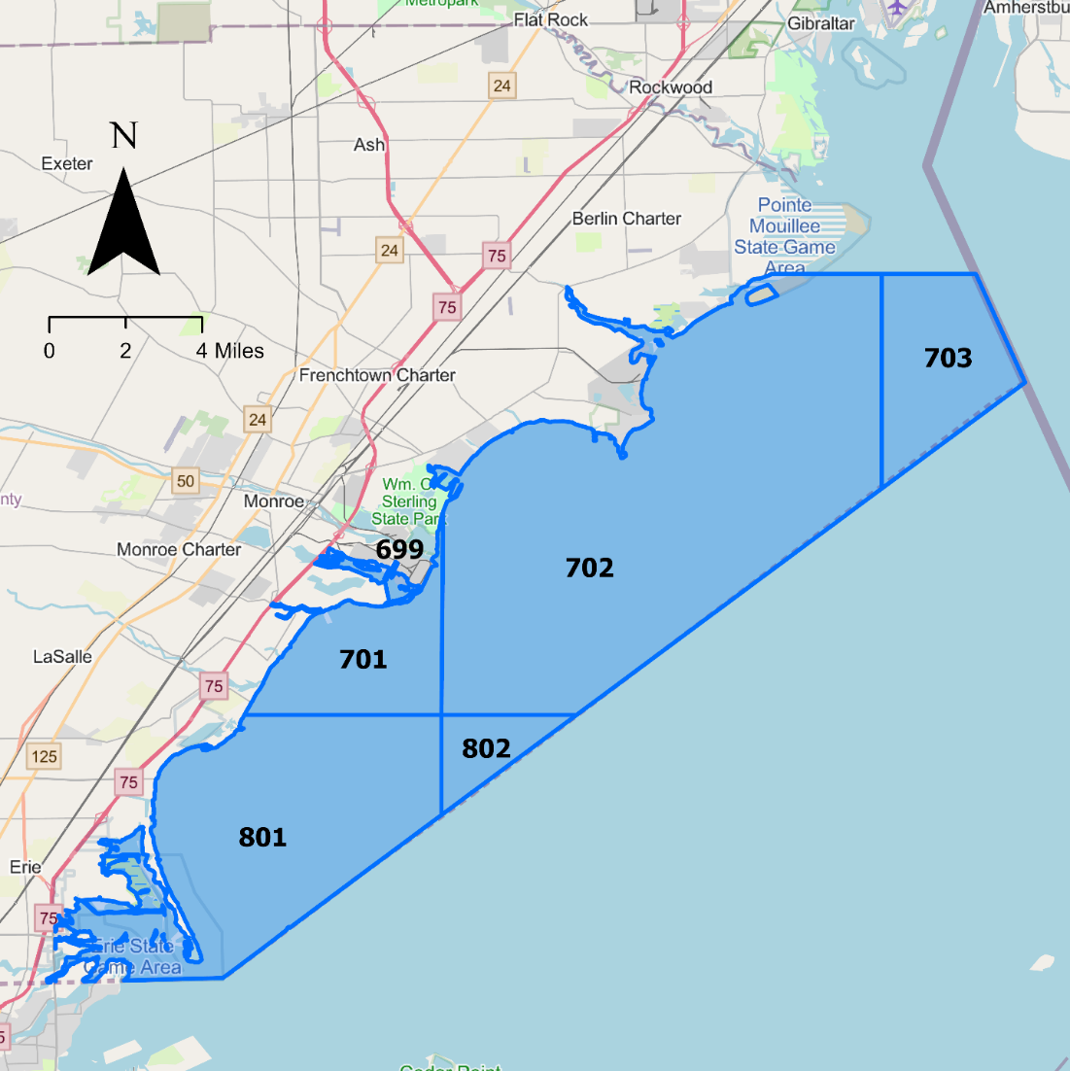

Figure S7. Lake Erie 2025 release estimates (number of fish). OTH = combined harvest of all other species not shown individually. Species abbreviations can be found in Table A2.
